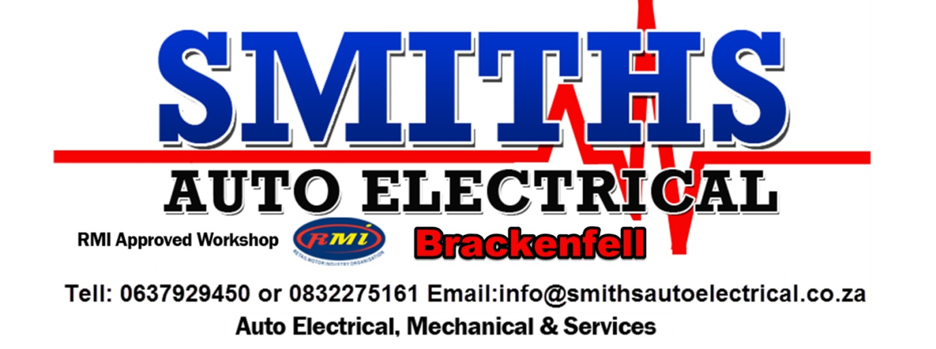
Smithsautoelectrical1@gmail.com
SERVICES
*Auto Electrical
*Basic + Major Services
*Alternators
*Motors/Starters
*Shocks
*Brakes
*Batteries
*Radiators
*Wheel Bearings
*73 Point Checks & Report
*Aircon Re-gas and repairs
*Computerized Diagnostics
*Electric Window Mechanism & Regulator Repairs
To Avoid Disappointments Call Today!!!!!!!! Book with Us!!!! Call or email for a FREE QUOTE

SERVICE & 73 POINT CHECK
- ENGINE & CLUTCH
- INSPECT EXHAUST / PIPING FOR LEAKS AND DAMAGE.
- CHECK V-BELTS
- CHECK RADIATOR, HOSES AND CLAMPS
- CHECK COOLING SYSTEM LEVEL AND TOP UP, IF NECESSARY
- INSPECT FOR OIL AND WATER LEAKS
- CHANGE ENGINE OIL
- REPLACE OIL FILTER
- REPLACE AIR FILTER AND CLEAN AIR FILTER HOUSING
- REPLACE FUELL FILTER
- REPLACE CONDENSOR, IF APPLICABLE
- REPLACE SPARK PLUS AND CHECK PLUG LEADS
- ADJUST IDLING AND CO CONTENT
- CHECK GEARBOX OIL LEVEL, CHECK DIFF OIL LEVEL
- CHECK CLUTCH FLUID
- CHECK SPEEDOMETER, CHECK OIL PRESSURE GUAGE, CHECK FUEL GUAGE
- CHECK WATER TEMPERATURE GUAGE
- CHECK VALVES
- CHECK DISTRIBUTOR
- CHECK CARBURETTOR
- CHECK SUMP THREAD
- CHECK CAMBELT
- CHECK LEAKS ON INJECTORS
- CHECK COIL PACKS

- FRONT AND REAR SUSPENSION STEERING
- INSPECT BALL JOINTS AND CONTROL ARMS
- INSPECT STEERING RACK AND STEERING RACK BOOTS
- CHECK TIE ROD ENDS
- CHECK CONSTANT VELOCITY JOINTS AND BOOTS
- INSPECT ALL SUSPENSI0N RELATED BUSHING
- CHECK REAR WHEEL BEARINGS
- CHECK REAR SHOCKS
- CHECK FRONT WHEEL BEARINGS
- CHECK FRONT SHOCKS
- CHECK SHOCKMOUNTINGS
- CHECK ENGINE MOUNTINGS
- CHECK PROPSHAFT

- BRAKES AND TYRES
    - INSPECT TYRES FOR ANY DAMGE, CHECK WHEEL BEARING
    - INSPECT WHEEL RIMS
    - CHECK BRAKES AND PADS
    - CHECK HANDBRAKE
    - CHECK AND TOP UP BRAKE FLUID
    - INSPECT BRAKE SYSTEMS FOR LEAKS
    - CHECK ANIT-RATTLE CLIPS, CHECK BBRAKE FLEXIBLE HOSES
    - ROTATE TYRES, IF REQUIRED
    - CHECK TYPE PRESSURE
    - CHECK WHEEL CAPS AND BOLTS

- BODY – EXTERIOR AND INTERIOR
- LUBRICATE BONNET, BOOT AND DOOR HINGES, CHECK BONNET RELEASE
- INSPECT UNDERBODY FOR ANY DAMAGE, CHECK BOOT RELEASE
- CHECK WINDOW WINDER AND DOOR MECHANISM OPERATION
- CHECK EXTERNAL BODY FOR DAMAGE, CHECK WINDOW TINTING
- CHECK ALL LENSES FOR CRACKS OR DAMAGE
- CHECK LOCKS, CHECK FUEL OR DIESEL CAP
- CHECK SEATBELTS, CHECK SUNVISORS, CHECK WINDSCREEN AND WINDOWS
- CHECK CENTRAL LOCKING AND ACTUATORS, CHECK SEAT RAILS

- ELECTRICAL SYSTEMS
- CHECK AND TOP UP BATTERY FLUID AND CHECK BATTERY CLAMPS
- CHECK OPERATION OF HOOTE AND LIGHTS, CHECK HAZARDS
- CHECK OPERATIOB OF WPERS, CHECK FUSES
- ADJUST WIBDOW WASHERS NOZZLES
- CHECK AND ADJUST FRONT HEADLIGHTS, IF NECESSARY
- CHECK HEATER AND AIRCON
- CHECK POLLEN FILTER
- LOAD TEST BATTERY, CHECK AERIAL, CHECK TOWBAR
- CHECK CHARGE RATE OF ALTERNATOR
- CHECK METERS & GUAGES, CHECK RADIO, CHECK CLOCK

Mervyn Goledberg
I just got my back from Smiths today-it a complex problem with the auto gearbox -these wonderful and professional auto electricians repaired it for less than a quarter of the price other firms had quoted me THEY ARE SIMPLY the BEST-They try very hard to help and not screw you like the other firms around town. Their work is excellent and completed to the very highest degree of excellence- DON'T GO ANY WHERE ELSE-these guys will look after you better than any other auto elec in the Western Cape. Great job - god bless you and my heartfelt thanks for a brilliant job

Janette de beer
Excellent service and advice

Callen Hodgskiss
Friendly, knowledgably service that was affordable. Thanks.

OUR WORKSHOP
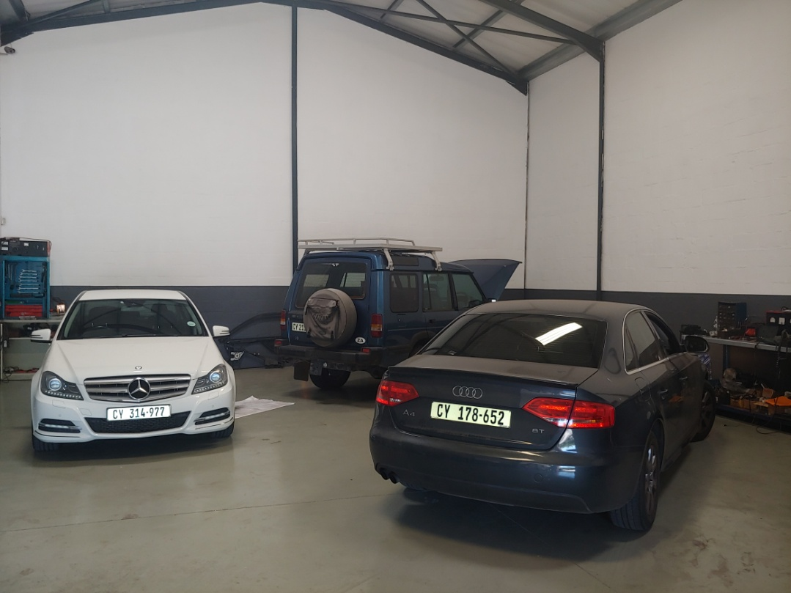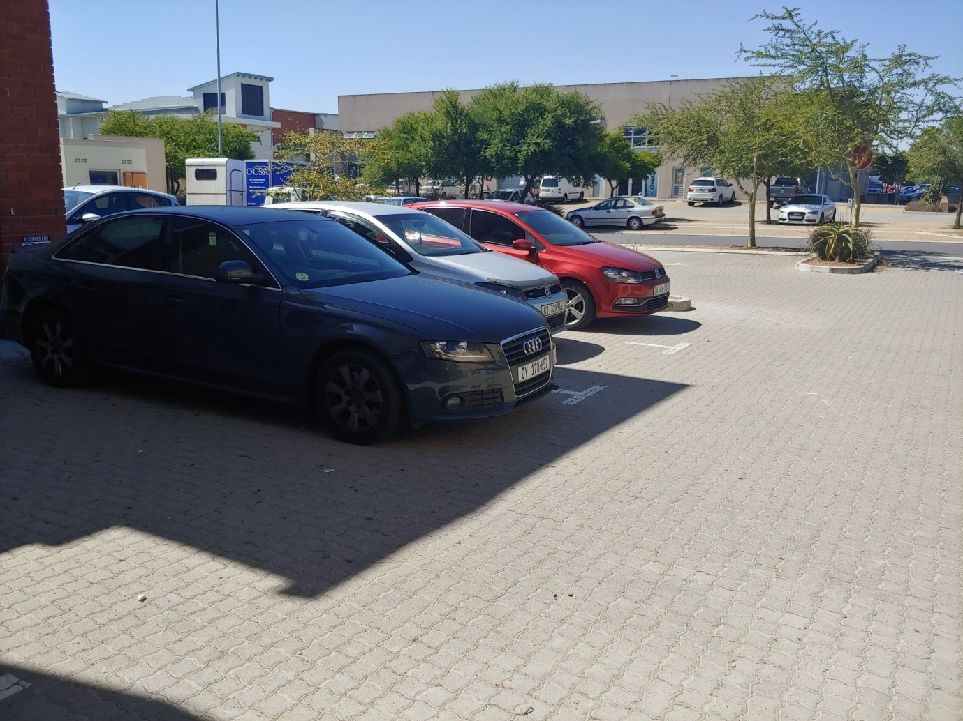
PRIZE WINNER:
