Accessories & 4 x4 Fitment Centre
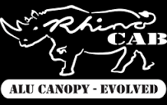
SMARTCANOPY®
RUBBERIZING OF BAKKIES/TRUCKS & EQUIPMENT
AUTOMOTIVE & CANOPY GLASS, CAB SLIDERS
CANOPY-COLOUR CODING • WINDOW TINTING • SMASH & GRAB
AUTOMOTIVE ACCESSORIES & 4 X4 EQUIPMENT
• 4 x 4 REPLACEMENT BUMPERS & ROCKSLIDERS
• BULL BARS • NUDGE BARS • TOW BARS • ROLL BARS
• SECURI-LID • TONNEAU COVERS • SIDE STEPS • LED SPOT LIGHTS
• CAR RADIOS • ROOF RACKS • ROD HOLDERS • STOCKMAN RAILS
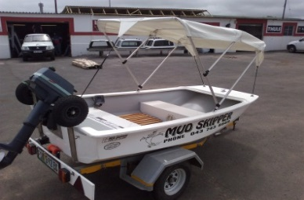
FIBREGLASS
- MUDSKIPPER BOATS • CANOPY REPAIRS, BOATS & CANOES etc,
• MOTORCYCLE BOXES • TRACTOR TOPS
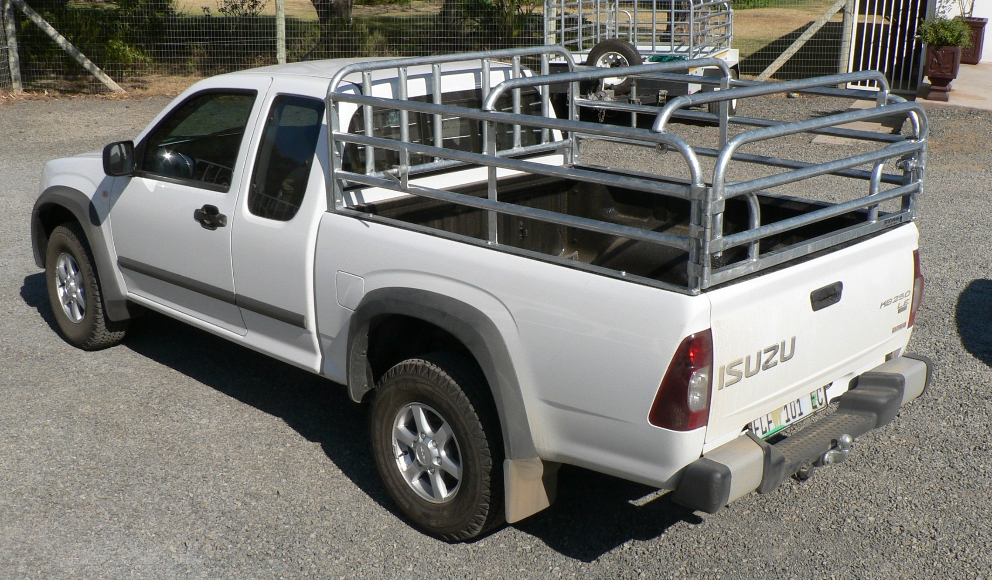
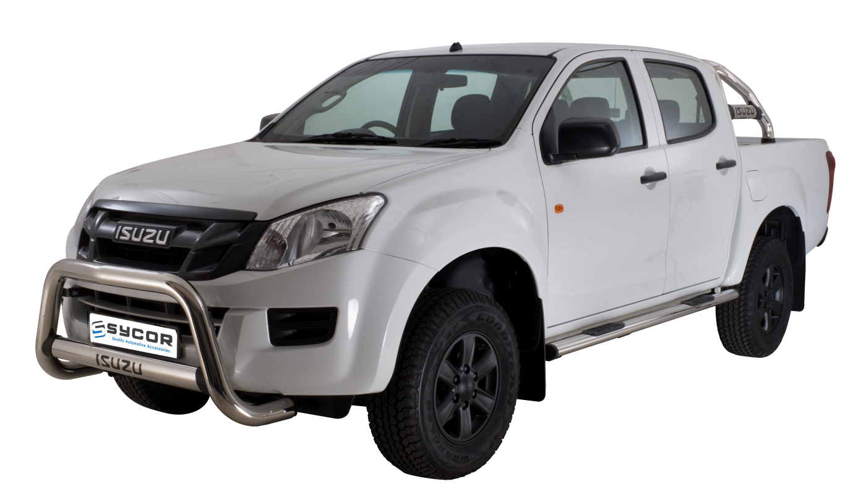
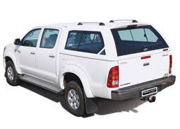
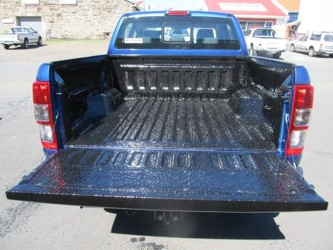
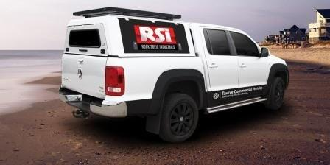

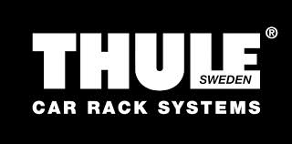
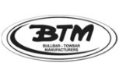
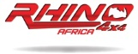
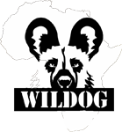
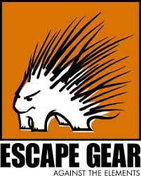
Unit 18, Arcadia Park, Commercial Road, East London
www.ultraguard.co.za
Ph: 043-743 8669 / Fax: 043 – 743 4101 / ultraguard@tcguysa.co.za

